2017-2018 Annual Partnership

HERE’S HOW YOUR GENEROSITY HELPS
- Provides safety and collection materials for cleanups.
- Provides materials for Keep Blount Beautiful’s education programs on litter prevention, waste reduction, recycling, and environmental sustainability.
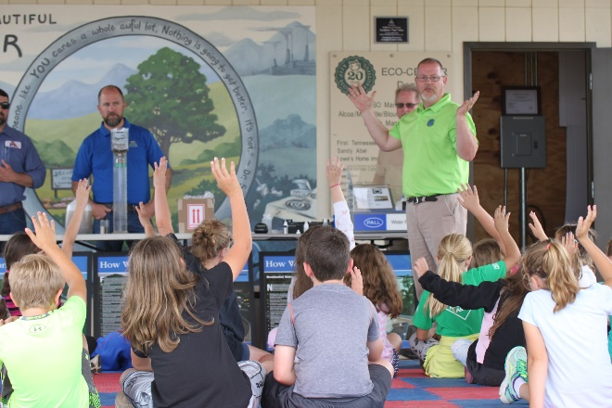
- Provides recycling and collection materials for creating waste-free events.
- Contributes to local recycling and anti-littering promotional campaigns.
Keep Blount Beautiful educated 3,971 students in the 2016-2017 year.

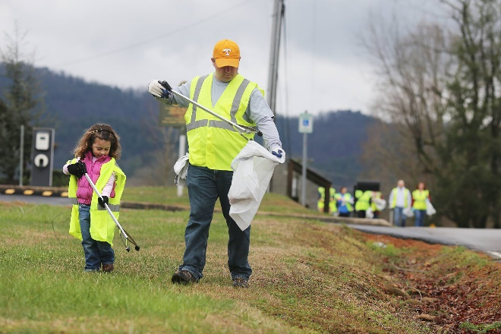

3,649 volunteer hours were served this past year.

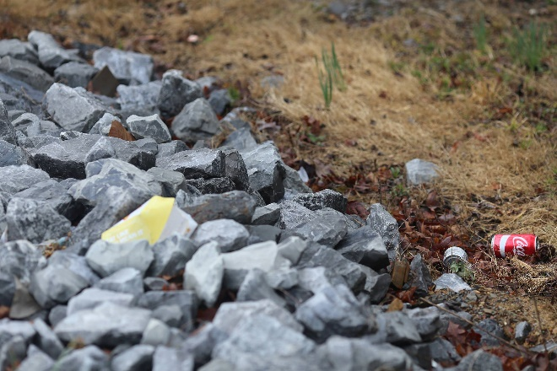

About 25,270 pounds of litter was removed from Blount County roads, waterways, and parks last year.

Partner Benefits | Sponsor |  |  | Partner |  | Friend
 | $5000 | $2500 | $1000 | $500 | $250 | $100 | $50
Recognized as the Keep Blount Beautiful “Sustaining Partner” at the BRAVO! Awards | X
Feature about sponsor in e-newsletter | X | X
Recognition of your support in all press releases/marketing/promotional material | X | X | X
Company logo on e-newsletter for one year | X | X | X
Company logo and link on Keep Blount Beautiful website for one year | X | X | X
Logo on event banners | X | X | X
Acknowledgements of your contribution during events | X | X | X
5 tickets to the BRAVO! Awards Luncheon | X | X | X
2 tickets to the BRAVO! Awards Luncheon |  |  |  | X
Name Listed on Website |  |  |  | X | X | X
Keep Blount Beautiful Water Bottle | X | X | X | X | X
Keep Blount Beautiful Sticker | X | X | X | X | X | X | X

In-Kind Sponsor: Sponsorship benefits dependent upon donated item or service. Please contact Executive Director for details and opportunities you would like to offer.
Please contact Alanna McKissack at (865) 681-4809 if you have comments or questions. We are available to meet with you, make a presentation and work with you in any way.

